

REVISION 1.0



**AUTHORS**

Anubha Sharma

Priyam Dua

Arshdeep Kaur

Harjinder Gill

Tanya Agrawal

Avinash Gupta

Shaftkat Waheed

Roxy Lenoard Palma

# objective of sprint

The objective of the sprint was to lay the foundation of the project and designing the basic architecture of the project and implementing few features. We planned the below task to achieve this goal

## user story 1. df

[CP8117P13-14](https://pmc.cs.uwindsor.ca/jira/browse/CP8117P13-14) Restaurant owner food creation and posting

## user story 2.

CP8117P13-13 Restaurant owner entry and interaction with our system.

# list of tasks or activities

For better understanding and work division, we divided tasks into the subtasks listed below.

## Subtask for user Story 1

|  |  |
| --- | --- |
| [CP8117P13-18](https://pmc.cs.uwindsor.ca/jira/browse/CP8117P13-18) | Create restaurant list page |
| [CP8117P13-19](https://pmc.cs.uwindsor.ca/jira/browse/CP8117P13-19) | Add food page |
| [CP8117P13-20](https://pmc.cs.uwindsor.ca/jira/browse/CP8117P13-20) | Food list API |
| [CP8117P13-21](https://pmc.cs.uwindsor.ca/jira/browse/CP8117P13-21) | Food creation api |
| [CP8117P13-23](https://pmc.cs.uwindsor.ca/jira/browse/CP8117P13-23) | Testing the Functionality |

1. **Subtask for user Story 2**

|  |  |
| --- | --- |
| [CP8117P13-15](https://pmc.cs.uwindsor.ca/jira/browse/CP8117P13-15) | Make login page and signup page |
| [CP8117P13-16](https://pmc.cs.uwindsor.ca/jira/browse/CP8117P13-16) | Login API |
| [CP8117P13-17](https://pmc.cs.uwindsor.ca/jira/browse/CP8117P13-17) | Signup API |
| [CP8117P13-22](https://pmc.cs.uwindsor.ca/jira/browse/CP8117P13-22) | Testing the Functionality |

# provisional planning

|  |  |  |  |  |  |  |
| --- | --- | --- | --- | --- | --- | --- |
| **JIRA ID** | **Start Date** | **End Date** | **Duration** | **Assignee** | **Dependabilities** | **Provisional Artifacts** |
| [CP8117P13-18](https://pmc.cs.uwindsor.ca/jira/browse/CP8117P13-18) | June 16 | July 2 | 30 hrs | Avinash Gupta | N/A | NA |
| [CP8117P13-19](https://pmc.cs.uwindsor.ca/jira/browse/CP8117P13-19) | June 16 | July 2 | 30 hrs | Arshdeep Kaur | N/A | N/A |
| [CP8117P13-20](https://pmc.cs.uwindsor.ca/jira/browse/CP8117P13-20) | June 16 | July 2 | 30 hrs | Shafkat Waheed | NA | Api-Documentation.pdf |
| [CP8117P13-23](https://pmc.cs.uwindsor.ca/jira/browse/CP8117P13-23) | June 16 | July 2 | 15 hrs | Harjinder Gill | CP8117P13-18, CP8117P13-19, CP8117P13-20  [CP8117P13-21](https://pmc.cs.uwindsor.ca/jira/browse/CP8117P13-21) | Testing.pdf |
| [CP8117P13-15](https://pmc.cs.uwindsor.ca/jira/browse/CP8117P13-15) | June 16 | July 2 | 30 hrs | Roxy Leonard Palma | N/A | N/A |
| [CP8117P13-16](https://pmc.cs.uwindsor.ca/jira/browse/CP8117P13-16) | June 16 | July 2 | 30 hrs | Anubha Sharma | N/A | Api-Documentation.pdf |
| [CP8117P13-17](https://pmc.cs.uwindsor.ca/jira/browse/CP8117P13-17) | June 16 | July 2 | 30hrs | Tanya Agarwal | NA | Api-Documentation.pdf |
| [CP8117P13-22](https://pmc.cs.uwindsor.ca/jira/browse/CP8117P13-22) | June 16 | July 2 | 30hrs | Harjinder Gill | CP8117P13-15  CP8117P13-16  CP8117P13-17  [CP8117P13-21](https://pmc.cs.uwindsor.ca/jira/browse/CP8117P13-21) | Testing.pdf |
| [CP8117P13-21](https://pmc.cs.uwindsor.ca/jira/browse/CP8117P13-21) | June 16 | July 2 | 15 hrs | Priyam Dua | N/A | Api-Documentation.pdf |

# effective planning

|  |  |  |  |  |  |  |
| --- | --- | --- | --- | --- | --- | --- |
| **Task Details** | **JIRA ID** | **Start Date** | **End Date** | **Duration** | **Assignee** | **Produced Artifacts** |
| Creation of page containing the list of restaurants - UI | [CP8117P13-18](https://pmc.cs.uwindsor.ca/jira/browse/CP8117P13-18) | June 18 | June 24 | 12 hrs | Avinash Gupta | N/A |
| Creation of add food page -UI | [CP8117P13-19](https://pmc.cs.uwindsor.ca/jira/browse/CP8117P13-19) | June 20 | July 2 | 8 hrs | Arshdeep Kaur | N/A |
| Creation of food list API | [CP8117P13-20](https://pmc.cs.uwindsor.ca/jira/browse/CP8117P13-20) | June 18 | July 2 | 10 hrs | Shafkat Waheed | Api-Documentation.pdf |
| Create and design the API for food creation/add page | [CP8117P13-21](https://pmc.cs.uwindsor.ca/jira/browse/CP8117P13-21) | June 21 | July 2 | 13 hrs | Priyam Dua | Api-Documentation.pdf |
| Testing the Functionality by doing checking restaurant list | [CP8117P13-23](https://pmc.cs.uwindsor.ca/jira/browse/CP8117P13-23) | June 28 | July 2 | 8 hrs | Harjinder Gill | Testing.pdf |
| Make login page and signup page - UI | [CP8117P13-15](https://pmc.cs.uwindsor.ca/jira/browse/CP8117P13-15) | June 23 | July 2 | 12 hrs | Roxy Leonard Palma | NA |
| Creation of login API | [CP8117P13-16](https://pmc.cs.uwindsor.ca/jira/browse/CP8117P13-16) | June 23 | July 2 | 16 hrs | Anubha Sharma | Api-Documentation.pdf |
| Creation of Signup API | [CP8117P13-17](https://pmc.cs.uwindsor.ca/jira/browse/CP8117P13-17) | June 28 | July 2 | 16 hrs | Tanya Agarwal | Api-Documentation.pdf |
| Testing the Functionality by doing signup/login | [CP8117P13-22](https://pmc.cs.uwindsor.ca/jira/browse/CP8117P13-22) | June 28 | July 2 | 8 hrs | Harjinder Gill | Testing.pdf |

# list of failures/ incomplete task

1. Few bugs were found during this milestone which would be fixed in the next sprint.

# Changes

1. Image section was newly identified and will be working on this in next sprint, we have introduced JPA in our project as a backend technology

# evaluation of the sprint

All the tasks assigned to the scrum team were completed within the given time frame. Total of 9 tasks were completed in this sprint.

Below are our learnings from this Sprint

1. Team was regularly logging their work on JIRA as discussed in last sprint by following proper workflow.
2. During this sprint, we found out that we assigned team members with their respective roles weather be it for front-end or back-end for creating APIs, but we didn’t create any specific task for the integration of both and hence faced a little issue at the last but eventually everything was completed before time.
3. While working on the sprint, we found out that one of the tasks mentioned in milestone 2 was dependent on another task of milestone 3 and hence we had to swap those tasks.

**SPRINT BURNDOWN CHART**

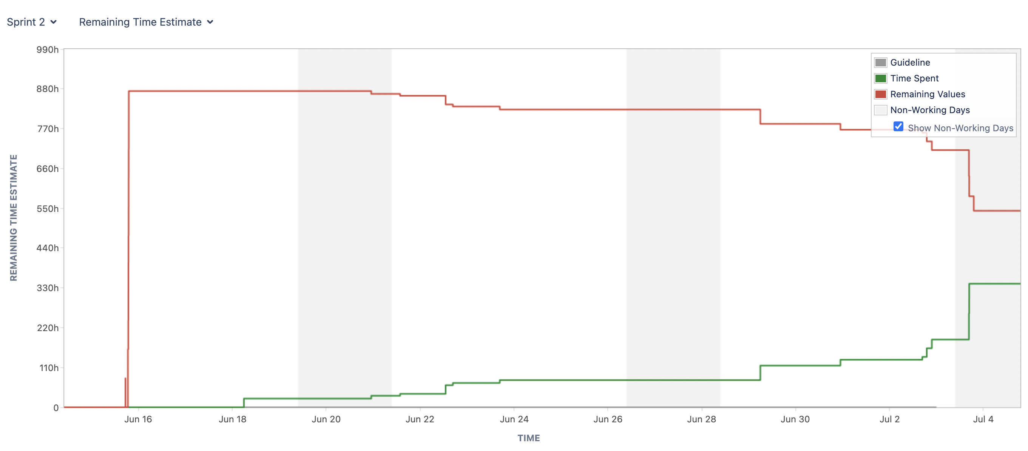

Link for complete burndown chart with detailed report – [Click Here](https://pmc.cs.uwindsor.ca/jira/secure/RapidBoard.jspa?rapidView=22&projectKey=CP8117P13&view=reporting&chart=burndownChart&sprint=107)